UNSW Electrical Engineering 1965 Class Photo

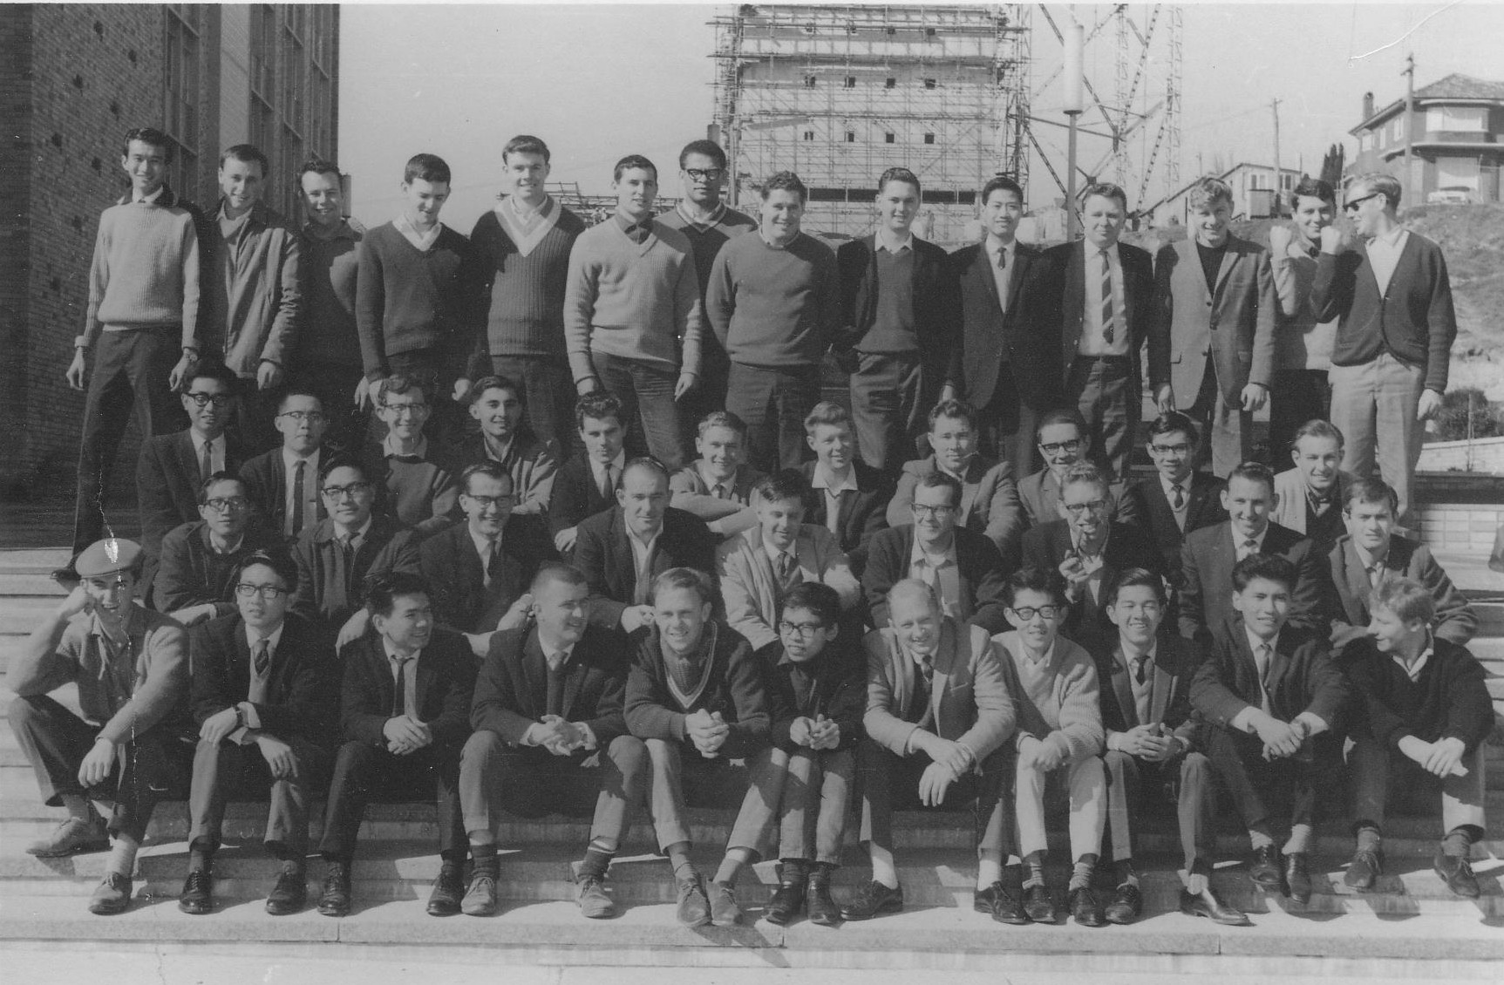

Back Row L-R: Kum Seng Ho, Ben Grabovsky, Graham Bradley, Dave Carpenter, Bob Mitchell, Geoff Poulton, Bill Gonelevu, John Vanny, Bruce Sharpham, Hin Biu Thomas Fu, John Wood, Tony Landon, Tom Geczy, Graham Pont

Third Row L-R; Meng Siong Ee, Carl Hing Ying Lam, Keith Robards, Tony Markus, George Terei, Kevin Phillips, Greg Barnicoat, Harry Dunne, Henry Coupe, Tony Chan, Bob Myers

Second Row L-R; Edwin Chan, John Wong, Bill Carroll, Ian Hagan, Bill Brennan, Peter Lowrie, John Greenway, Malcolm Smith, Col Burg

Front Row L-R; Tony Peebles, Hua Nam Lim, Hiang Wang, Jim Myers, Brian Ducker, Ron Widarsito, John Davies, Sio Ma Sung, Boon Ka Chew, Bob Lee, Bob Finlay
1966 Graduation List

